
PORT HARCOURT
APEX INTEGRATED TECHNOLOGIES LTD.
Digital Forensic Incident Response Unit

CASE ID: AIT-DF-2026-009
INVESTIGATION TYPE: DIGITAL FORENSICS/DELETED DATA RECOVERY
EVIDENCE TYPE: FORENSIC DISK IMAGE
INVESTIGATOR: HARCOURT JOEL JUNIOR
TEAM: FORENSIC ANALYSTS
DATE: 25TH SEPTEMBER, 2026

USING DD
We hashed the forensic image and compared it with the working copy which borught out the same result, meaning that it is still intact.

USING RDRIVE
The forensic image was acquired using FTK Imager in E01 format. While FTK Imager and Autopsy could analyze this format, R-Drive Image display the forensic image because .E01 files are not supported formats for R-Drive.

USING FTK IMAGER
A. SSH: Identified in the file system tree with a red "X" icon, confirming that the folder was deleted.
B. Corel draw work: Identified in the file system tree with a red "X" icon, confirming that the folder was also deleted.
C. Corel: Identified in the file system tree with a red “X” icon, confirming that the folder was deleted.
D. Unlocated / Missing Target Folders:
My pic, Our pic, ADDS Project, and were not located within FTK Imager's directory.
- The presence of red "X" indicators on SSH, corel draw work and corel verifies active file deletion on the evidence drive.
- The absence of the remaining four folders (My pic, Our pic and ADDS Project) indicates that their directories may have been overwritten, altered, or wiped.

USING AUTOPSY
A. SSH: This was found but it was listed under deleted files.
B. Corel: This was also found but it was under deleted files.
C. Corel draw work: This was found but it was listed under deleted files.

PHASE 1
Evidence Filename & Extension: Evidence.E01
Evidence Size (Bytes / GB): 10MB
Image Format (E01, RAW/DD, VHD, etc.): E01
Partition(s) Identified:
File System(s) (NTFS, FAT32, exFAT, etc.)
Operating System Identified: Windows 10 Pro
User Account(s) Identified: Harcourt Joel Junior
Acquisition Date/Time (If logged)
SHA-256 Hash Value: 6216149fddf6eb7074349afaef226f02c3b246ee6c3c3aae91c5ab7adeb8c29e0
MD5 Hash Value (If calculated): None

PHASE 2
Hash Algorithm: SHA-256
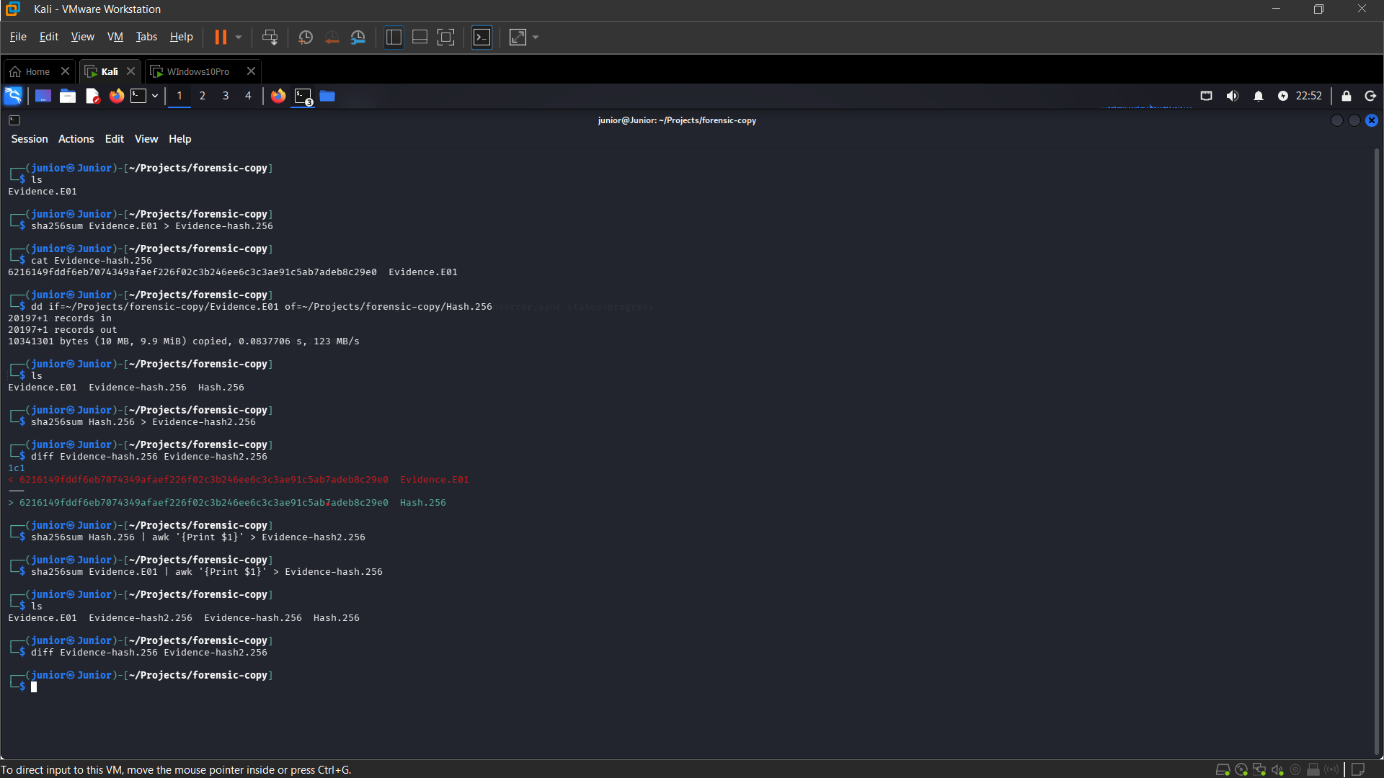
This is the evidence showing the working copy and original hash. This shows that the evidence is still the same and has not been tampered with. If it shows otherwise, it means that the evidence has been overwritten or altered.

PHASE 3
SSH: Identified in the file system tree with a red "X" icon, confirming that it existed but was deleted. It is a directory that contains pdf files that can be partially recovered.
Corel draw work: Identified in the file system tree with a red "X" icon, confirming that the it existed but was also deleted. It contains images, corel documents and a zip file. It can be partially recovered.
Corel: Identified in the file system tree with a red "X" icon, confirming that the it existed but was also deleted. It contains templates, resources and tools used in CorelDraw. The deleted items in this folder can be partially recovered but cannot be used in the design environment.
Unlocated / Missing Target Folders:
My pic, Our pic, ADDS Project, and were not located within FTK Imager's directory.
- The presence of red "X" indicators on SSH, corel draw work and corel verifies active file deletion on the evidence drive.
- The absence of the remaining four folders (My pic, Our pic and ADDS Project) indicates that their directories may have been overwritten, altered, or wiped. It means that they can no longer be recovered and are permanently lost, so, there’s no way to know what exactly was in each of them.

RECOVERED
These are what was recovered;
1. SSH:
Path: Evidence.E01/New Volume/[root]/SSH
Size: 4.56MB
Tool Used: Autopsy

2. Corel:
Path: Evidence.E01/New Volume/[root]/Corel
Size: 63.1MB
Tool Used FTK Imager

3. Corel draw work:
Path: Evidence.E01/New Volume/[root]/corel draw work
Size: 202MB
Tool Used: Autopsy

TIMELINE INVESTIGATION
SSH:
Created: 2026-09-24T11:39:46+1:00
Modified: 2026-09-24T11:45:41+1:00
Accessed: 2026-09-24T11:45:41+1:00

Corel draw work:
Created: 2026-09-24T11:42:36+1:00
Modified: 2026-09-24T11:42:36+1:00
Accessed: 2026-09-24T11:42:36+1:00

Corel:
Created: 2026-09-24T11:40:08+1:00
Modified: 2026-09-24T11:44:41+1:00
Accessed: 2026-09-24T11:44:41+1:00

